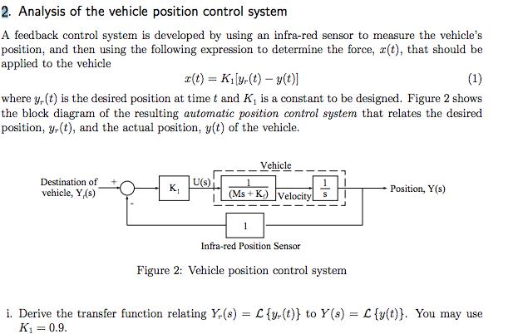
ii. Determine the poles of the automatic controlled vehicle.
iii. If the vehicle is now at the start position when t = 0 and it needs to move to a location that is 100 m away from the starting point. How can you model the input signal, yr(t)?
iv. Derive and sketch the trajectory of the vehicle under closed loop control
v. Suppose the vehicle is now loaded in such a manner that its closed loop controlled behaviour is altered significantly. You may take ”significant” to mean a change in response from oscillatory to non-oscillatory or non-oscillatory to oscillatory - depending on the parameters of the vehicle you have. Describe a scenario (by giving values for relevant parameters) in which a significant change in behaviour can happen. Analyze this behaviour and sketch the trajectory of the vehicle.
vi. Is it possible to re-design the value of K1 to get a better response from your vehicle? Support your answer with an analysis.

